AWS-SECRET MANAGER
First go to AWS RDS → Create database, select MariaDB,
choose Free tier,
enter DB instance identifier and master username,
then enable Managed in AWS Secrets Manager and click Create database.
After that, go to RDS → Databases and check the database status as Creating and wait until it becomes Available.
Finally, open AWS Secrets Manager, select the auto-created RDS secret (rds!db-...) and view the username and password stored inside it
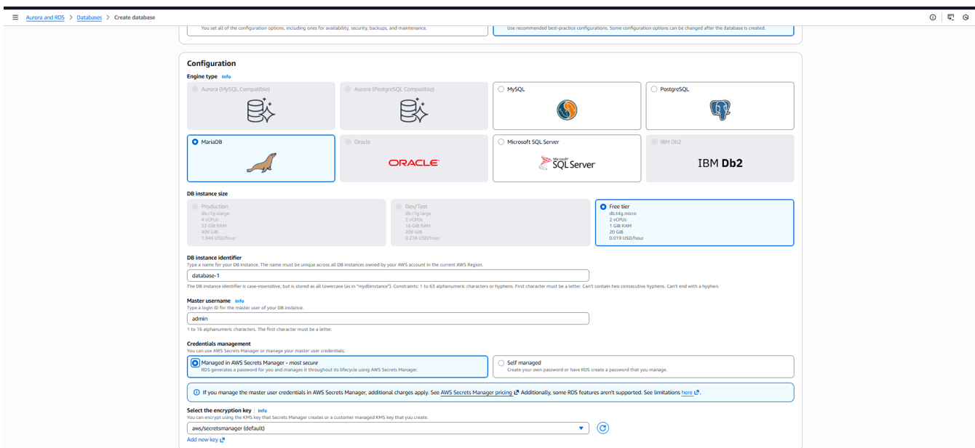

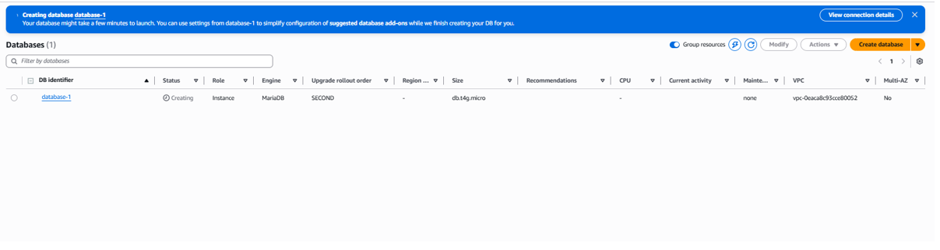
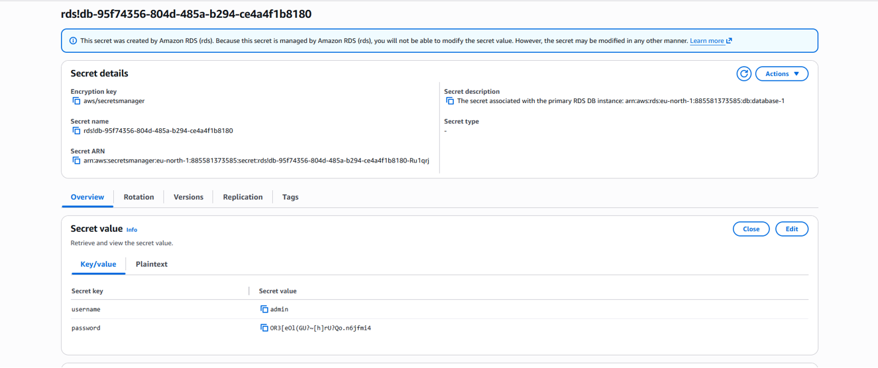

Now open AWS Secrets Manager → Store a new secret, select Credentials for Amazon RDS database, enter the required username and password, select the DB instance, and click Next. In the next step, provide a secret name (example: demo/secret) and proceed further to create it. After successful creation, verify the new secret is visible in the Secrets list, then open it to view full details like username, password, engine, host (endpoint), port, and DB instance identifier for application/database connection.
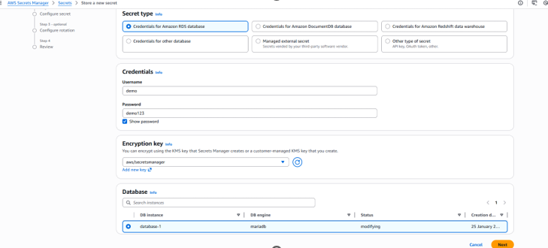
You give any name in our case we have given demo/secret
